Website Plan

## Project summary

* The website I chose is: <https://www.islandmusicfest.com/>   
  The page lacks design and has a lot of content, making it difficult to navigate the website. I believe this type of site has the potential to create an attractive and user-friendly page
* Explain why the client needs a new website:
  + *what is the most important purpose of this website*:  
    The most important purpose of this website is to provide information about the music festival on the island.
  + *why is their current site not appropriate:*   
    Their current site is not appropriate because it lacks design and contains a substantial amount of content, making navigation challenging. The absence of an appealing design and the overwhelming content negatively impact the user experience, hindering the effective communication of information about the music festival. Therefore, a new website is needed to address these issues and create a more engaging and user-friendly platform.
* What is the overall message you are trying to convey to your target audience on this website?   
  The overall message I aim to convey to the target audience on this website is the excitement and essence of the island music festival. Through a redesigned and user-friendly platform, I seek to enhance the user experience, facilitating navigation and access to information about the festival. The new website intends to communicate the vibrancy of the event, ensuring that visitors can easily understand, engage with, and immerse themselves in the unique experience offered by the music festival on the island.

## Target audience

* Who is the target audience? What do they care about? Perhaps there are multiple target audiences?

1.- Music Enthusiasts: Individuals passionate about different genres of music who are specifically interested in attending a music festival.

2.- Event Seekers: People looking for entertainment and events on the island, possibly tourists or locals interested in cultural experiences.

3.- General Audience: Individuals who appreciate the arts and cultural events, even if they are not necessarily hardcore music enthusiasts.

## Call-to-action priorities

What action do you want the audience to perform before they leave your website? Are there multiple ways they could take action?   
  
***Ticket Purchase:*** One primary action would be to prompt visitors to purchase tickets for the music festival directly through the website. This could involve providing clear calls-to-action and a streamlined ticket purchasing process.

***Event Information Access***: Encourage users to explore and access detailed information about the festival, including the lineup, schedule, venue details, and any other relevant information that enhances their understanding of the event.

***Social Media Engagement:*** Encourage visitors to connect with the festival on social media platforms. This could include following official accounts, sharing content, and participating in discussions, thereby extending the festival's reach.

***Newsletter Signup:*** Provide an option for visitors to subscribe to a newsletter. This would allow the festival to maintain communication with interested individuals, providing updates, exclusive content, and promotional offers.

***Feedback and Contact***: Invite users to provide feedback about the website or the festival itself. Include contact information for inquiries, creating an avenue for interaction.

## Look and feel

Good references can be found all over: [Coolors](https://coolors.co/), [Adobe Color](https://color.adobe.com/search), [Pinterest](https://pinterest.com/), [Behance](https://www.behance.net/), [Dribbble](https://dribbble.com/), [Instagram](https://www.instagram.com/), [Typewolf](https://www.typewolf.com/), [Unsplash](https://unsplash.com/), [Adobe Fonts](https://fonts.adobe.com/), [Ouch!](https://icons8.com/ouch), [Icon Store](https://iconstore.co/), and [Font Squirrel](https://www.fontsquirrel.com/matcherator).

* **Mood:**

Aim for a modern and trendy look to reflect the current and relevant aspects of the music industry and festival culture.

* **Inspiration:**Draw inspiration from creative platforms like Behance and Dribble to infuse artistic and inspiring elements into the design, reflecting the creativity associated with music festivals.  
  [**https://www.bonnaroo.com/**](https://www.bonnaroo.com/)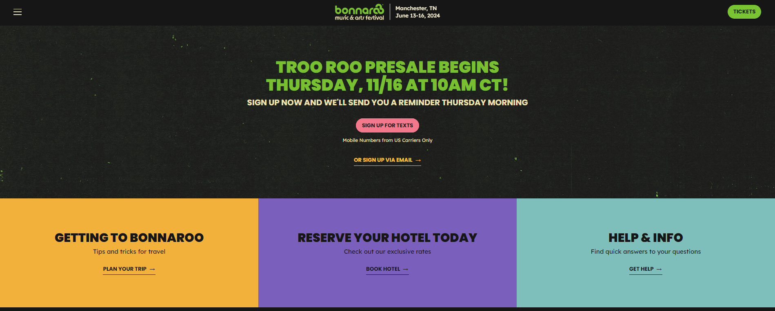

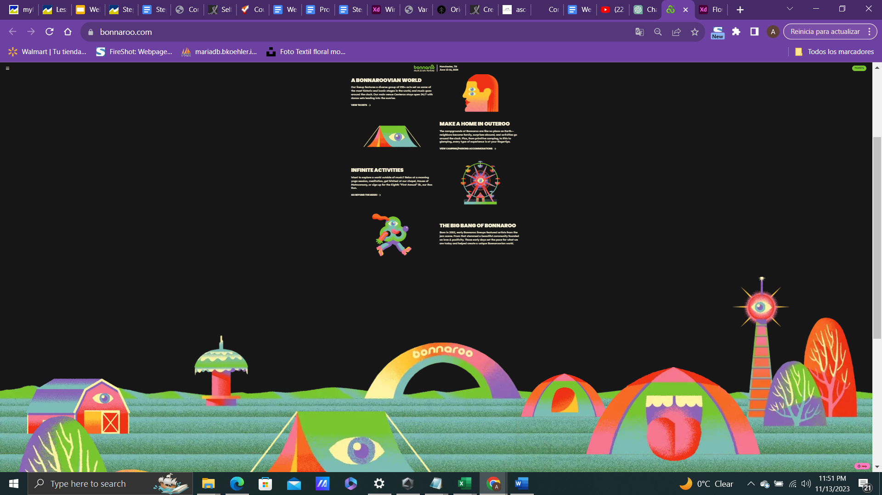  
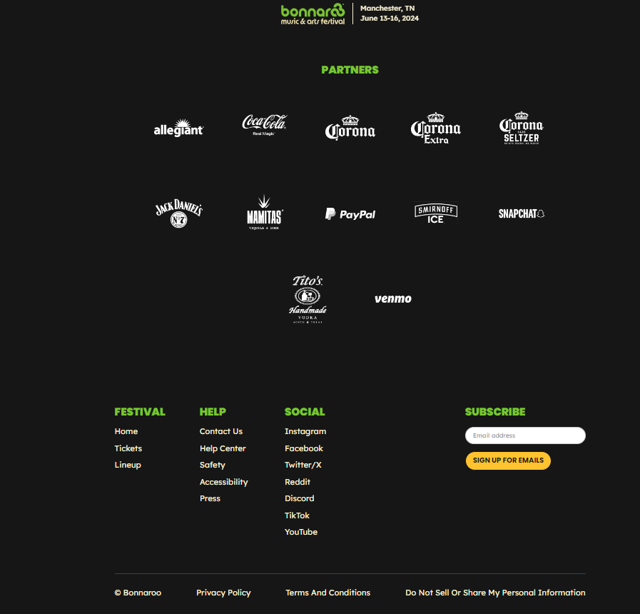

<https://www.coachella.com/>

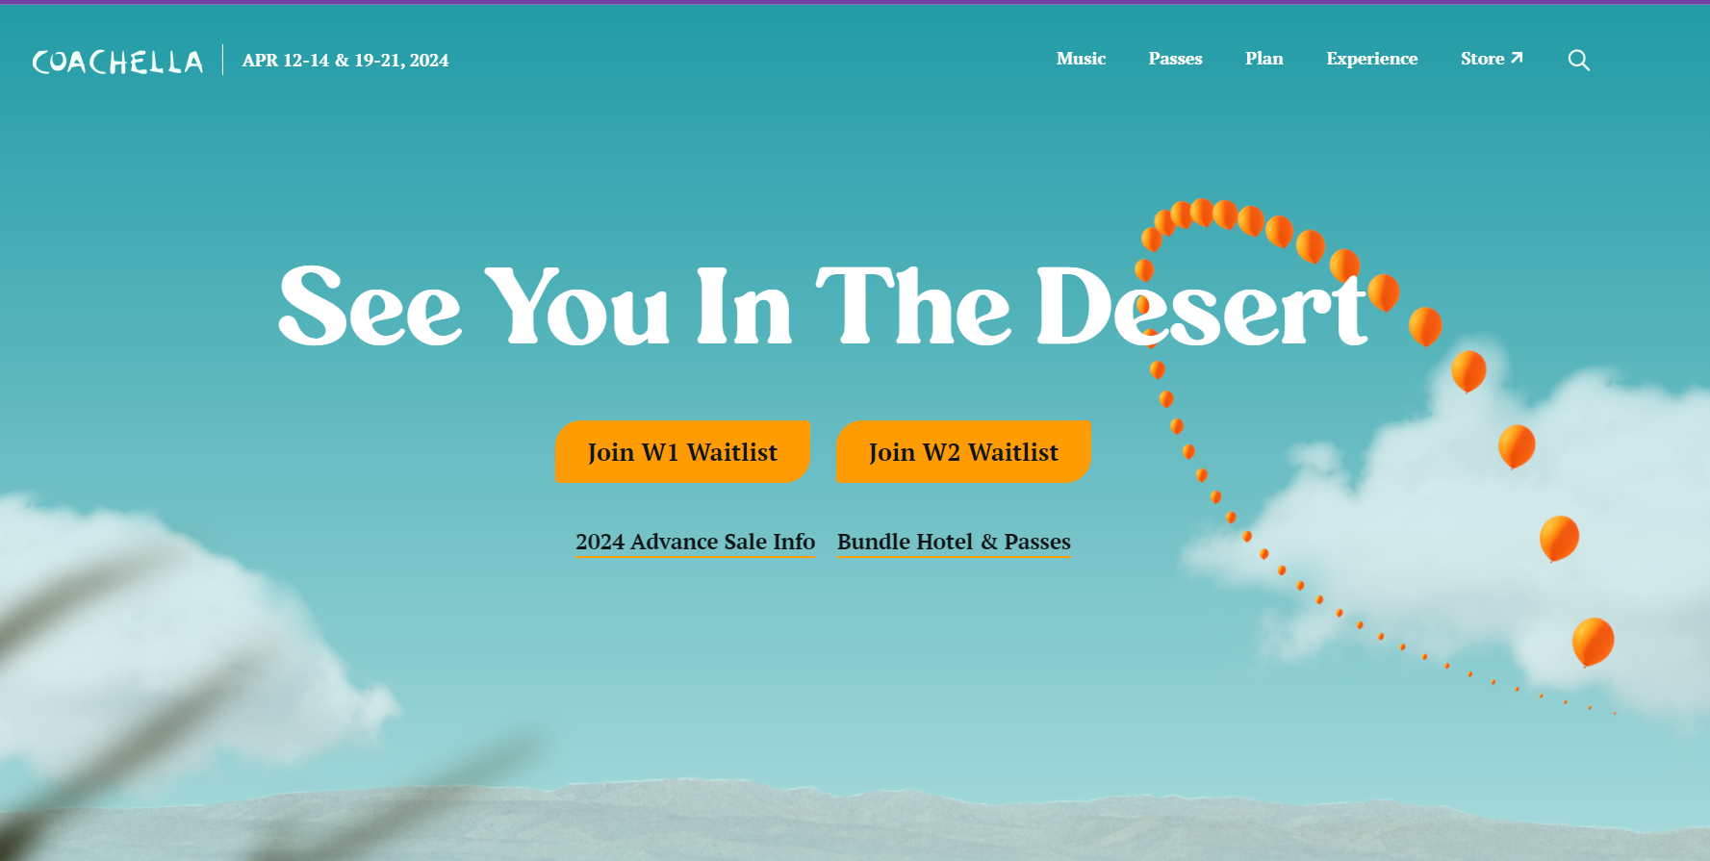

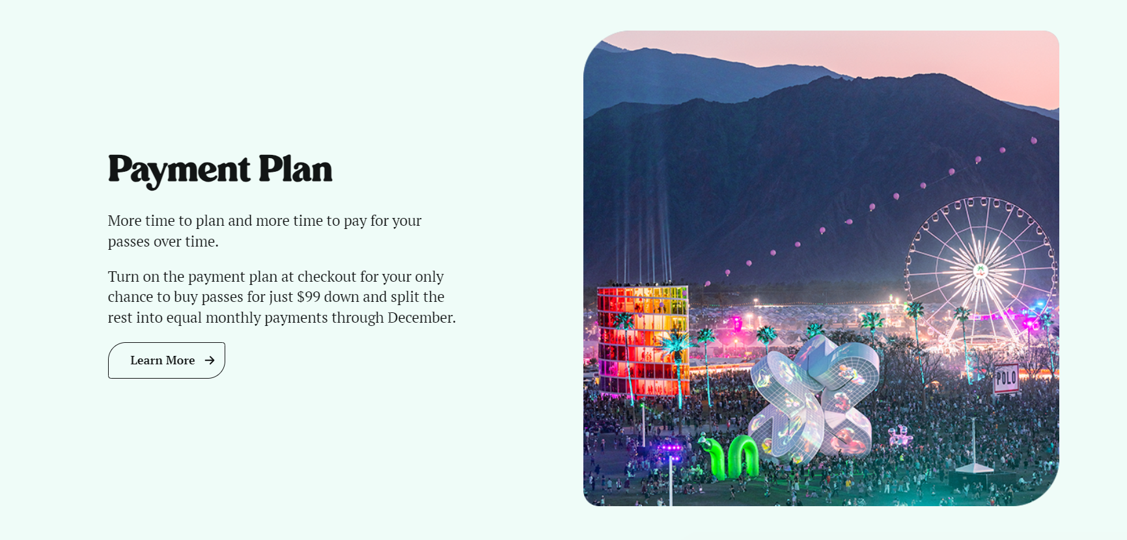

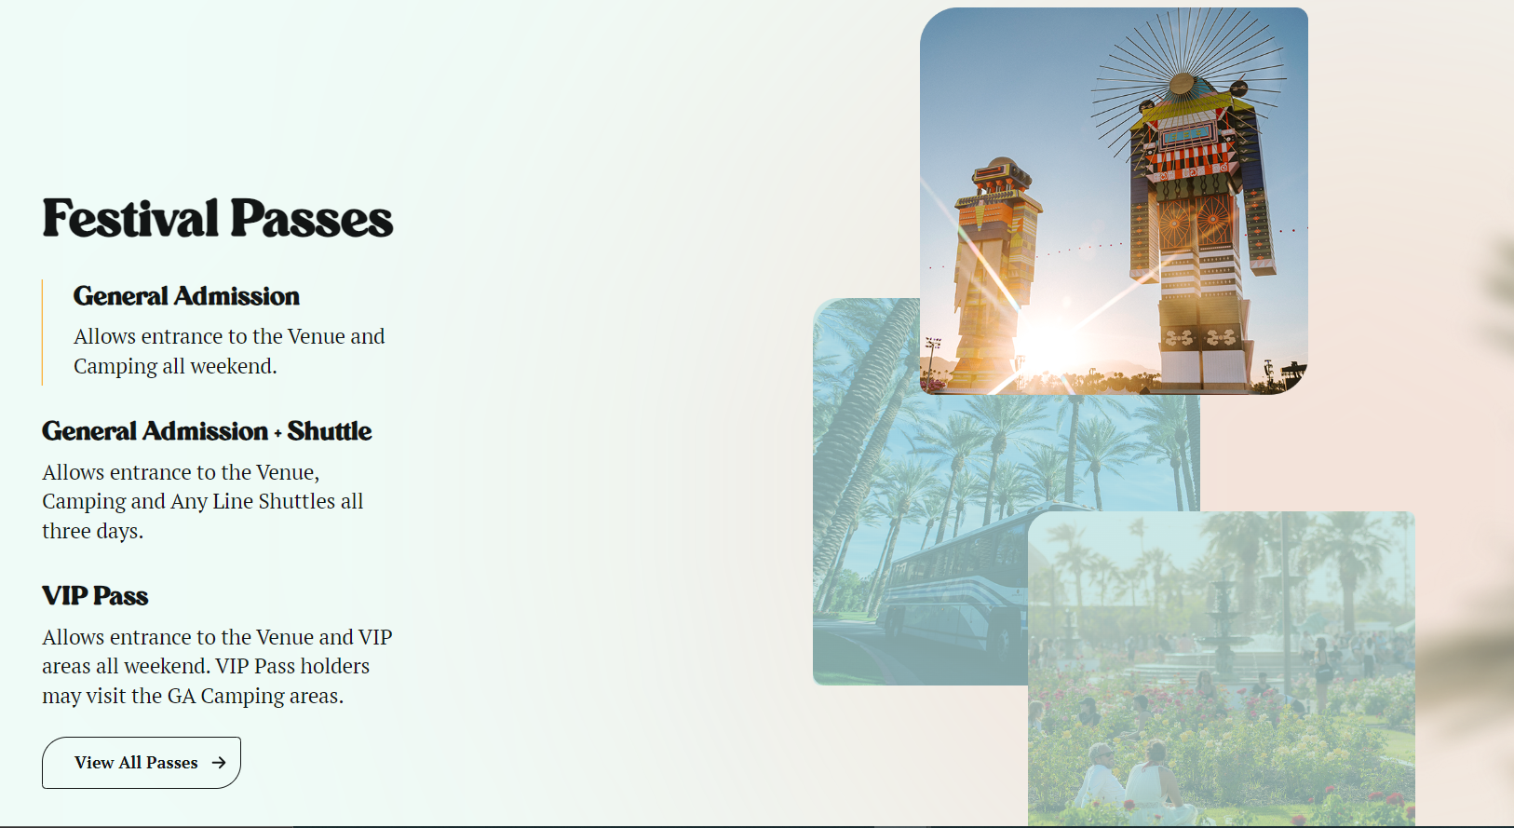

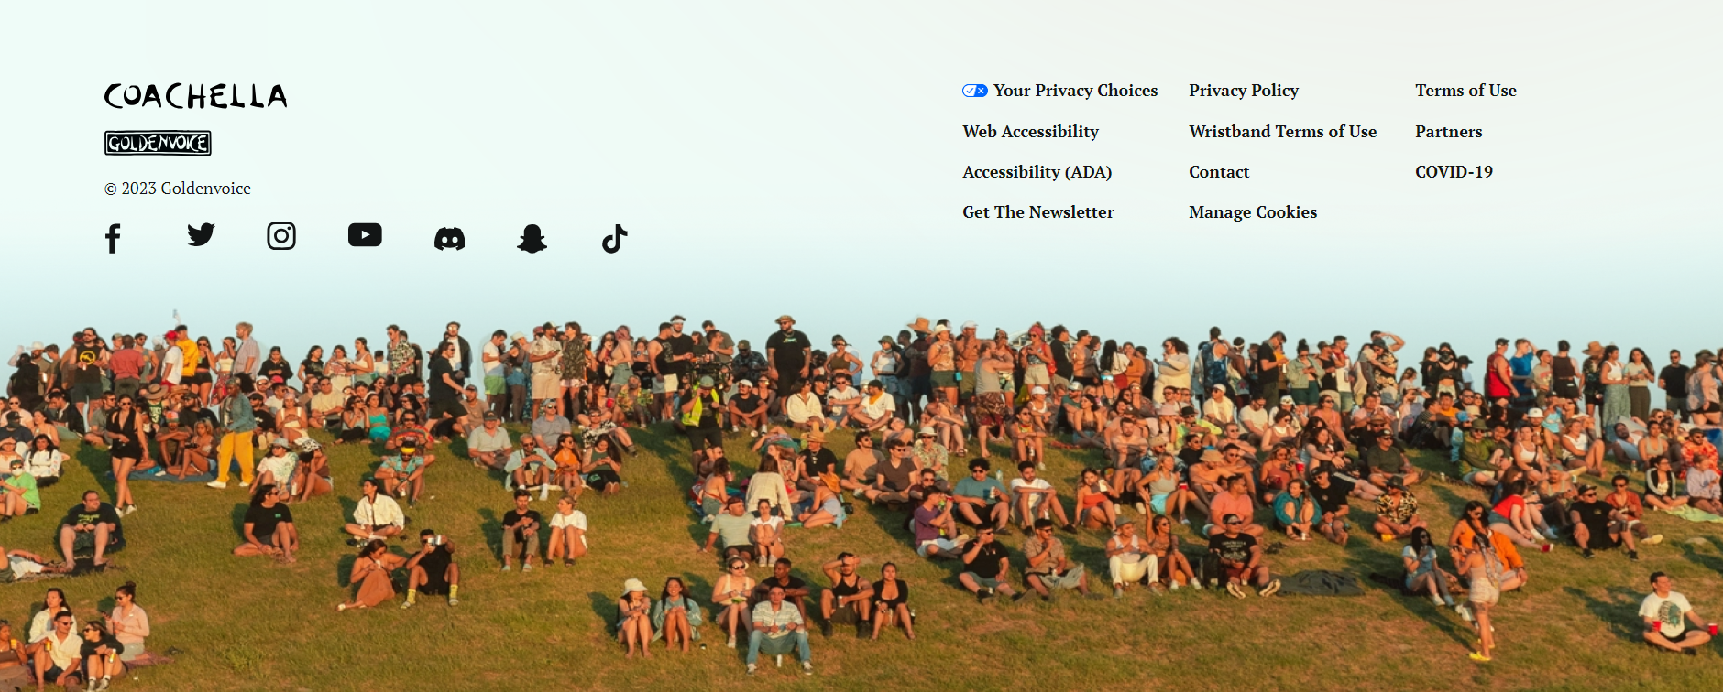

* **Colours:**Incorporate a vibrant color palette to create a playful and engaging visual experience, aligning with the festive and celebratory nature of the event. (Yellow, black, magenta).
* **Images:**   
  Utilize high-quality and impactful visuals, possibly from sources like Unsplash and Instagram, to convey the unique atmosphere and experiences offered by the music festival.
* **Fonts:**   
  Explore font options from Adobe Fonts and Font Squirrel to achieve a harmonious and visually appealing typography that complements the overall design.  
  *font-families*  
  headlines: Playfair Display / lobster / bebas Neue  
  Body: pacifico / Raleway / Roboto / Monserrat

## Content

* You only need to build 3 pages, including the homepage. List the 3 pages that you will redesign: I will redesign: homepage, Ticket Purchase Page, Event Information Page.
* For those 3 pages **list the content blocks that will appear on each page** (include what content you think each content block will include):  
  * navbars

* content

* features

* benefits

* Calls to action

* pricing tables

* footer

* Contact

* Review the Website Technical Requirements from the Project Overview document to make sure that you have included all the content you need to.

|  |
| --- |
| Example: Below are the content blocks from 2 sample pages for a business that offers graphic design services. This is only to be used as an example of how you should list the content that you will include in your website.  **Home page**   1. Header    * Main navigation 2. Hero    * Heading    * Image    * Link to Portfolio page 3. About    * Heading    * Paragraph    * No link 4. Benefits    * Heading    * List of 3 reasons why our company is the best    * Link to Why Work With Us page 5. Portfolio    * Heading    * List of 6 cards that each advertise one project (heading, image and link in each card)    * Link to Portfolio page 6. Call-to-action    * Heading    * Link to Contact page 7. Footer    * Heading    * About paragraph    * Main navigation    * Copyright   **About us page**   1. Header (*same as on homepage)* 2. Small Hero    * Heading    * Image 3. Our History    * Heading    * Image    * Paragraphs 4. The Team    * Heading    * Cards for each team member (Name, job title and image in each card) 5. Our Skills    * Heading    * List of skills, each skill is paired with an image 6. Call-to-action (*same as on homepage)* 7. Footer (*same as on homepage)* |